 | COLLEGE OF COMPUTING AND INFORMATION SCIENCES
 | Mid-Term Assessment Fall 2020 Semester
Class Id | 105150,105151,105152 | Course Title | OOAD
Program | BSCS | Campus / Shift | Main Campus / Morning
Date | 19th October 2020 | Total Marks | 30
Duration | 02 hours | Faculty Name | Mohammad Ayub Latif/Aleenah Khan
Student Id | 63758 | Student Name | Ali Salman Hassan

Instructions:
- Filling out Student-ID and Student-Name on exam header is mandatory.
- Do not remove or change any part of exam header or question paper.
- Write down your answers in given space or at the end of exam paper with proper title “Answer for Question# _ _”.
- Answers should be formatted correctly (font size, alignment and etc.)
- Handwritten text or image should be on A4 size page with clear visibility of contents.
- Only PDF format is accepted (Student are advised to install necessary software)
- In case of CHEATING, COPIED material or any unfair means would result in negative marking or ZERO.
- A mandatory recorded viva session will be conducted to ascertain the quality of answer scripts where deemed necessary.

- Caution: Duration to perform Mid-Term Assessment is 02 hours only. Extra 01 hours are given to cater all kinds of odds in submission of Answer-sheet. Therefore, if you failed to upload answer sheet on LMS (in PDF format) within 03 hours limit, you would be considered as ABSENT/FAILED.

Note: All questions carry equal marks.

Question 01:
Draw a class structure for the following scenario:
There’s a university where teachers conduct workshops in which students can register. A teacher has a name, telephone number, email address, address, and salary. A student has the same details except the salary. Additionally, a student also has an average mark. A workshop has a name and an id. When a student registers in a workshop, the marks for this enrollment are recorded and his/her current average marks can be obtained from the enrollment. From a student one can access a list of workshops he or she is registered in. Teachers conduct workshops. There are two types of workshop: beginner and advanced. From a beginner workshop student cannot withdraw. From an advanced workshop they can. Link the classes which would need to communicate with other class through their objects. Also define what relationships can be used among the classes so that their objects can communicate with each other. The properties and the methods of the classes should be clearly drawn in the class structure.
Answer for Question#01:
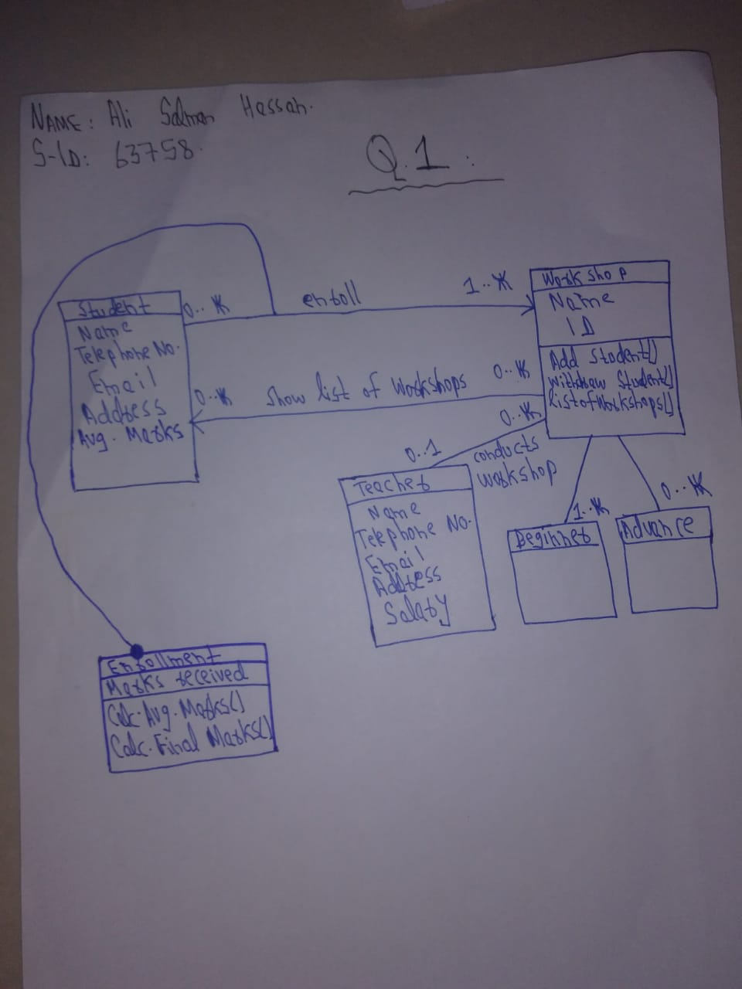

Question 02:
Draw complete Use Case Diagram for the following scenario and show all <<include>> and <<extend>> stereotypes:
User browses catalog & chooses item(s) to purchase. User proceeds to check out. User provides details for shipping (address, next-day-delivery or 1-week-delivery). Website displays billing information. User provides credit card information. Website authorizes the purchase. Website confirms order and also sends confirmation email to customers.
Answer for Question#02:
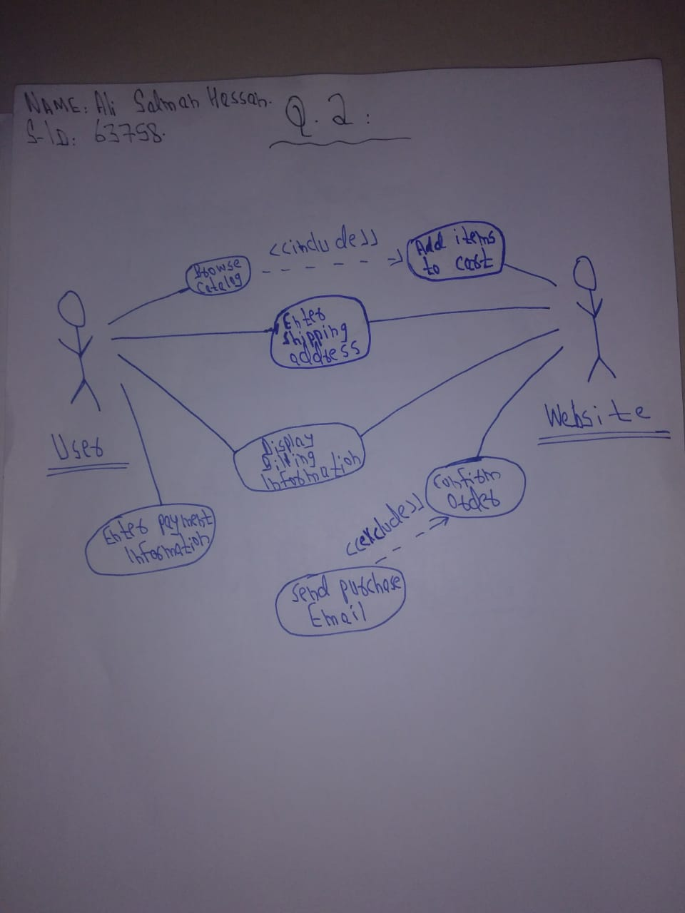

Question 03:
What is the importance of sequence diagram and why do we need to create it? For any one of the use case from Question number 2, write down the flow of events of any one-use case and draw its complete sequence diagram and also provide its complete running code in any object-oriented language.
Answer for Question#03:

Flow of events for Add items to cart():
Main flow:
First user will browse the catalog and will select an item to purchase and will add add the item to the cart.
Sub flow:
User can drop an item if cart gets full and can leave the cart.
Alternative flow:
User cannot checkout without selecting an item to purchase.

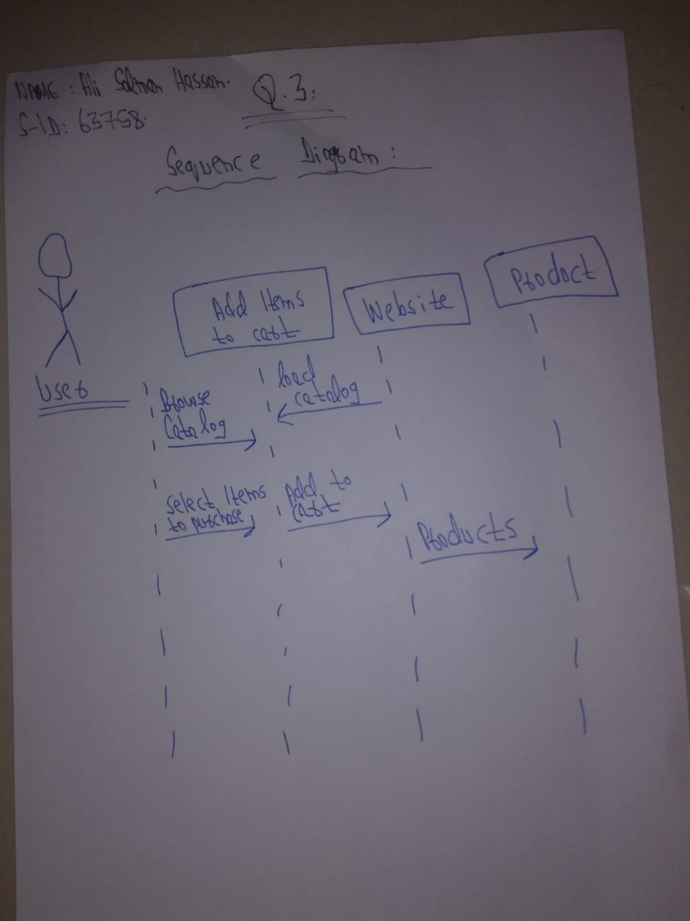

CODE:
class Products{
string p_ID;
string p_Name;
string p_Category
public Product(string id,string name,string category){
p_ID = id;
p_Name = name;
p_Category = category;
}
}

class website{
public void add_to_cart(string x,string y,string z){
products p1 = new products(x,y,z);
}
public void load_catalog(){
product p1 = new product();
}
}
Private void button1_click(object sender eventargs){
website w = new website();
w.add_to_cart(text1.text,text2.text,text3.text);
}

private void onload(object sender eventargs){
website w = new website();
w.load_catalog();
}

Question 04:
Differentiating between sequential and iterative models, discuss the advantages of iterative model and specify that which methodology is followed USD/RUP. Write down all the important features of USD/RUP and discuss its phases and workflows in detail. Use diagrams for proper explanation in your answer.
Answer for Question#04:
DIFFERENCE:
In sequential model goals are defined for each phase by defining entry and exit criteria and delivering artifacts phase wise whereas in iterative model the completion of analysis and design for a set of features is done by one team followed by completion of code and test by another team.
ADVANTAGES OF ITERATIVE MODEL:
- Generates working software quickly and early during the software life cycle
- More flexible and less costly to change scope and requirements
- Easier to test and debug during a smaller iteration
- Easier to manage risk because risky parts are identified and handled during its iteration

RATIONAL UNIFIED PROCESS(USD/RUP):
The key features of the Unified Process are iterative and incremental development framework. It allows you to deal with changing requirements regardless of whether they are coming from the customer or from the project itself. It emphasizes the need for accurate documentation. Following are the phases below
• Inception: In this phase, you'd collect requirements from the customer and analyze the project's feasibility, its cost, risks, and profits.
• Elaboration: This phase include creating fully functional requirements (use-cases) and creating a detailed architecture for fulfillment of the requirements.
• Construction: This phase includes the construction or working on the product.
• Transition: This phase includes to roll out the fully functional system to customers.
There are two types of workflows
• Process Workflow
Business Modeling:
Requirements: The primary activities of the Requirements workflow are aimed at building the use case model which captures the functional requirements of the system being defined.
Analysis and Design: The primary activities of the Analysis workflow are aimed at building the analysis model, which helps the developers refine and structure the functional requirements captured within the use case model. The primary activities of the Design workflow are aimed at building the design model which describes the physical realizations of the use cases from the use case model and also the contents of the analysis model.
Implementation: The primary activities of the Implementation workflow are aimed at building the implementation model which describes how the elements of the design model are packaged into software components such as source code files etc.
Test: The primary activities of the Test workflow are aimed at building the test model which describes how integration and system tests will exercise executable components from the implementation model. The test model also describes how the team will perform those tests as well as unit tests.
Deployment: The primary activity of the Deployment Workflow is released to the public. Final adjustments or updates are made based on feedback from end users
• Supporting Workflow
1) Configuration Management.
2) Management.
3) Environment.

Best of Luck 😊

